**Experiment 10 Date:** 03/04/2023

**Aim:**

Familiarization of Linux Commands

**Course Outcome(CO4):**

Write shell scripts required for system administration

**Procedure:**

1. Shell script to add two number:

vi filename.sh

Press ‘i’ to INSERT

#!/bin/bash

value=`expr 2 + 13`

echo "Total value : $value"

Press ‘Esc’ to end INSERT

:wq!

chmod +x filename.sh

./filename.sh

Output:



1. Write a shell script to initialize two numeric variables. Then perform addition operation on both values and store the result in the third variable.

vi filename.sh

Press ‘i’ to INSERT

#!/bin/bash

num1=12

num2=48

sum=$(( $num1 + $num2 ))

echo "Sum : $sum"

Press ‘Esc’ to end INSERT

:wq!

chmod +x filename.sh

./filename.sh

Output:



1. Shell script to read two numbers as command line parameters and perform the addition operation

vi filename.sh

Press ‘i’ to INSERT

#!/bin/bash

sum=$(( $1 + $2 ))

echo "Sum : $sum"

Press ‘Esc’ to end INSERT

:wq!

chmod +x filename.sh

./filename.sh num1 num2

Output:

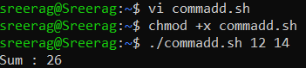

1. Shell script which takes input from the user at run time and then calculate the sum of given number and store to a variable and show the result

vi filename.sh

Press ‘i’ to INSERT

#!/bin/bash

read -p "Enter the First number: " num1

read -p "Enter the Second number: " num2

sum=$(( $num1 + $num2 ))

echo "Sum : $sum"

Press ‘Esc’ to end INSERT

:wq!

chmod +x filename.sh

./filename.sh num1 num2

Output:

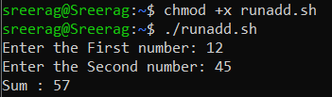

1. Shell script to demonstrate Arithmetic operators (addition, subtraction, multiplication, division, modulus, increment, decrement) by taking user input and store to another variable

vi filename.sh

Press ‘i’ to INSERT

#!/bin/bash

read -p "Enter the First number: " num1

read -p "Enter the Second number: " num2

sum=$(( $num1 + $num2 ))

prd=$(( $num1 * $num2 ))

diff=$(( $num1 - $num2 ))

quo=$(( $num1 / $num2 ))

rem=$(( $num1 % $num2 ))

echo "Sum : $sum"

echo "Product : $prd"

echo "Difference : $diff"

echo "Quotient : $quo"

echo "Remainder : $rem"

if [ $num1 == $num2 ]

then

echo "$num1 is equal to $num2"

fi

if [ $num1 != $num2 ]

then

echo "$num1 is not equal to $num2"

fi

(( ++num1 ))

echo "Increment operator on first number: $num1"

(( --num2 ))

echo "Decrement operator on second number: $num2"

Press ‘Esc’ to end INSERT

:wq!

chmod +x filename.sh

./filename.sh

Output:

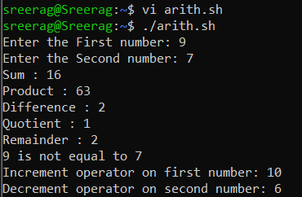

**Result:**

Output displayed successfully and CO4 was obtained.